**German University Bangladesh**

**Department of**

**Computer Science & Engineering**

**Project Report on**

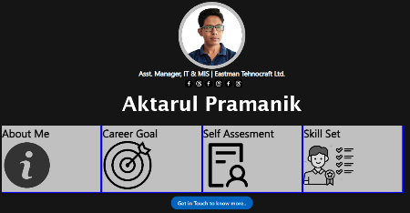**Personal Portfolio**

**Project Live Link:** [**https://aktarulp.github.io/portfolio/**](https://aktarulp.github.io/portfolio/#home)

**Module Name : E-Commerce & Web Engineering**

**Module Code : CSE-422L**

SUBMITTED TO:

Rafat Ara

Assistant Professor

Department of

Computer Science & Engineering

German University Bangladesh

SUBMITTED BY:

Md. Aktarul Pramanik

ID No. 20-2-08-001

Batch: 9th (Diploma)

Semester: Summer-2023

Date of Submission: 29th September 2023